Contents

**The best evidence post** 2

Opening statements 4

SOCIAL MEDIA POSTS 5

• *Opening statements* 5

• *This is nonsense, ridiculous, won’t waste my time* 7

• *You’re a heretic. We have no common ground.”* 8

• *When they refuse to answer your specific question* 9

• *You are confused by different versions and how its translated* 10

• *I don’t have an answer, but the Bible can’t change PERIOD* 11

• *I’m not going to talk about this anymore* 11

• *This is foolishness* 12

• *This cant be true because the Bible has been preserved* 13

• *Nothing has changed because it’s always said “The wolf will dwell with the lamb”* 13

• *Is it heresy if…..* 14

• Examples of the Bible changing - Scripture changing scripture 17

• *This is a doctrine of demons* 18

• *These conspiracy topics just make people feel special* 19

• *You are preaching another gospel* 20

• *Explaining the doctrine of preservation* 20

• *Isn’t God strong enough to preserve the scriptures* 21

Bible scholar 24

Objections of the unconvinced 25

The evidence 26

Large scale of the phenomenon 27

Vast number, severity and variety of changes 27

We’re not delusional 29

Testimonial evidence & mathematical probabilities 29

Chat GBT Question 30

Chat GBT Answer 30

Take the quiz 35

If they got at least five (5) wrong the same way 38

Misquotes from pop culture (Telephone game) 39

Is the human memory is unreliable? 40

Once misremembering, misquotes from pop culture, delusion, confused by bible versions, modernization and misprints, implanted thoughts, biblical illiteracy have all been set aside 41

God preserves His word - the Bible can’t change 44

Evidence that the term “scripture” and the term “the Word” are not the same. 44

Different ways scripture refers to itself 47

Different meanings from original language 48

Different Terms used to describe the different gospels 48

Singular vs plural 49

Scripture is not the Word 49

The devil isn't that powerful 50

You're confused by different versions 50

You're confused because you're biblically illiterate 51

You're confused by implanted thoughts 51

You're charlatan or a deceiver 51

You're deceived by a government psyop 52

Prophecy foretelling the event 52

Examples of where God removed His word as a judgement 53

Examples of where the Bible changed 54

Patriarch names are not transliterations 57

Patriarch’s names are altered 57

Noah vs Noe proves that these are not “transliterations (KJV ONLY) 58

Not completed yet

* *Your confused by not understanding the underlying meaning*
* *This is a distraction to get your eyes off of Christ*
* *This is a psyop*
* *Your delusional*
* You just came here to pick a fight
* *You need to study the Bible more, your Biblically illiterate*

**The best evidence post**

People aren't misremembering....they're misremembering the SAME WAY! The probability of only 5 people misremembering only 5 different Bible quiz questions the same way, by chance, is approximately 10^25  
Anyone reading this can get every person in the world that knows their Bible to misremember the same way virtually every time with at least 10 to 15 scriptures. This is not improbable; it is statistically impossible. This completely objective observation sets aside all of the following objections:  
• We are misremembering  
• We're confused by different bible versions  
• We're confused by misquotes from pop-culture  
• We're confused because of modernizations  
• We're confused because of misprints

Here are 5 passages that virtually everyone will misremember the same way, and none of the explanations shown above will explain how that can happen. The chances of it happening by chance is 10^25  
In every case the objections above would result in people misremembering differently or not at all, not in unison. Unless you can provide a rational explanation for how everyone is misremembering in unison than you will be forced to consider that God is sending an Amos 8:11 type judgement on His church for turning the Bible into an idol.  
  
Matthew 7:1 KJV "Judge not, ______ ye be judged."  
WHAT WE REMEMBER  
Judge not, LEST ye be judged."  
ACTUAL  
Judge, not THAT ye, be not judged  
Job 1:21 (KJV) "Naked came I out of my mother's womb, and naked shall I return thither: the Lord ________ and the Lord ________away; blessed be the name of the Lord."  
WHAT WE REMEMBER ....the Lord GIVETH and the Lord TAKETH away; blessed be the name of the Lord."  
ACTUAL ".... the Lord GAVE, and the Lord HATH TAKEN away; blessed be the name of the Lord."  
Exodus 12:29 " (All Versions) And it came to pass, that at midnight the _______smote all the firstborn in the land of Egypt  
WHAT WE REMEMBER  
"And it came to pass, that at midnight the DEATH ANGEL smote all the firstborn in the land of Egypt, from the firstborn of Pharaoh that sat on his throne unto the firstborn of the captive that was in the dungeon; and all the firstborn of cattle."  
ACTUAL "And it came to pass, that at midnight the LORD smote all the firstborn in the land of Egypt, from the firstborn of Pharaoh that sat on his throne unto the firstborn of the captive that was in the dungeon; and all the firstborn of cattle."  
Genesis 32:24-25 (All versions) "And Jacob was left alone; and there wrestled an _________ with him until the breaking of the day.  
WHAT WE REMEMBER "And Jacob was left alone; and there wrestled an ANGEL with him until the breaking of the day.  
ACTUAL "And Jacob was left alone; and there wrestled a MAN with him until the breaking of the day.  
Genesis 8:11 (All versions) "And the dove came in to him in the evening; and, lo, in her mouth was an olive _____ plucked off:  
WHAT WE REMEMBER "And the dove came in to him in the evening; and, lo, in her mouth was an olive BRANCH plucked off: so Noah knew that the waters were abated from off the earth."  
ACTUAL "And the dove came in to him in the evening; and, lo, in her mouth was an olive LEAF plucked off: so Noah knew that the waters were abated from off the earth."

Opening statements

Were you aware that there are millions of people that are now claiming that there are hundreds of things in reality that they vividly remember that are no longer as they remember them. Its called the Mandela Effect

1. _______ _______ on the wall…who’s the fairest one of all”

(Magic mirror / Mirror mirror)

1. Grand Central _______ Place for trains in NY City (Station / Terminal)
2. “Smokey ____ Forest fire mascot Bear / the bear
3. ______Notes Book summaries of textbooks (Cliff’s notes / Cliff notes)
4. What was the name of the company that Ed Mcman delivered checks for when people won the sweepstakes - (He worked for American Family Publishers but he never delivered checks for them) (Publishers clearing house never hired him to deliver checks to people’s door
5. “Life _____ like a box of chocolates” Is/Was
6. It’s a beautiful day in _______ neighborhood (This/the)

SOCIAL MEDIA POSTS

* ***Opening statements***

ANSWER - I've recently decided that the Mandela effect phenomenon is authentic and the mysterious changes in our environment that everyone's talking about do in fact include the Bible. And the main reason that I have come to this conclusion has been the appalling reaction of most Christians to this topic.

The universal response of most Christians seems very suspicious to me. This topic is being avoided like the plague, and I have had to ask why is that?

My experience has been that the unconvinced on this topic always try to change the subject or immediately start hurling accusations with terms like conspiracy theory, heresy, or doctrine of demons.

I'm not a trouble maker; I'm a devout believer looking for answers. So is there anyone here that is willing to try to give me specific answers to my specific questions without changing the subject or resorting to decrees that the Bible can't change because I definitely disagree with anyone that says the Bible can't change and so do millions of other Christians.

If it was just a few people talking like that, I wouldn’t think anything about it

….but it is everyone. And this bizarre un-Christlike vitriol has made me very suspicious and forced me to go back and re-examine what the doctrine of preservation is actually teaching. And what I found was very surprising. I don’t know if you’ve ever really studied what theologians teach on the Doctrine of Preservation, I certainly hadn’t.

I don't believe that Satan has overpowered God any more than you do. But what most Christians haven’t considered is that God might be the one calling for this judgement. Amos 8:11 is only one example of how God has removed His word as a judgement, there are many more. I and others believe that He is doing this because His church has turned the Bible into an idol. What, you don't think that God's people have ever drifted into idolatry?

* ***This is nonsense, ridiculous, won’t waste my time***

Is this list nonsense? These are in virtually ALL Bibles. So are you willing to defend these abominations as being the inspired word of God, because I’m not, and millions of other Christians are not. What is the matter with you?

Are you really going to defend each one of these as the inspired word of God? Are you going to try to explain these paradoxes by suggesting that they are simply a bad translation when they appear in every translation?

You can’t explain these unexplainable nightmares by suggesting that I have cherry picked these from some rouge version and that there are versions out there that don’t have these awful passages in them. Well, these are in every version. So what’s your answer? Most Christians will also have to admit that this is the 1st time they have ever laid eyes on these passages. How is that possible?

How are you going to hold out the scriptures as being reliable, while simultaneously telling me its unreliable 11 different times in a row. Either the Bible is supernaturally changing or the translators are incompetent perverts so which one is it?

* Luke 19:27 (Jesus says) “But those mine enemies, which would not that I should reign over them, bring hither, and slay them before me.”
* 2 Kings 18:27 People drinking their own piss and eating their own dung
* (2 Cor 11:8) Paul was robbing churches
* Mark 8:23 – Jesus spits in people’s face to heal them
* Leviticus 4:32 - God instructs his people to sacrifice female sheep?
* Exodus 12:23 – God is killing the firstborn of Egypt  
  Isaiah 8:3 - Isaiah having sex with a prostitute and having a baby. And no, it wasn’t his wife and you know that was never in your Bible so stop lying to yourself.
* Zechariah 5:9 – Now there are female angels or women with wings
* Luke 18:15 – Jesus is touching babies
* Genesis 16:3 - Abram was married to Hagar

Isaiah 60:16 - “You will also suck the milk of nations, And suck the breast of kings;

* ***You’re a heretic. We have no common ground.”***

Explain how I’m a heretic for claiming that God is judging His church by making His word inaccessible, when the scriptures teach that God has done this at least 10 times before. Amos 8:11, Lamentations 2 Micah 3:6-7, Psalm 74:9, 1 Samuel 3:1, 2 Chronicles 15:3, Ezekiel 7:26, Hosea 4:6, Ezekiel 14:4,9, 1 Kings 22:19, Numbers 22:20, Psalms 18:26

Isn’t it appalling, that most Christians are comfortable with branding millions of professing Christians as heretics because they are testifying that the Bible is supernaturally changing? And they are doing this without even responding to our direct questions.

You say the Bible can’t change but it’s been changing since its inception. Explain how it’s heresy to claim that the scriptures do not teach preservation of the scriptures when large tracks of orthodox Christendom have held that position for centuries.

Your just confused because you believe what your told instead of the clear testimony of scripture. You’ve been led to believe that the terms Bible, Scripture and the word are synonymous, isn’t that right? And that’s why you’re mishandling the preservation promises. The scriptures don’t promise that the Bible or the scriptures will be preserved, God has only promised to preserve His word, and they are not the same.

* ***When they refuse to answer your specific question***

ANSWER Dodging questions like Neo dodges bullets in The Matrix!"

ANSWER It would seem that silence speaks louder than words—your refusal to answer tells me that you don’t have an answer to my question

ANSWER "A wise man gives an answer, but a fool avoids the question. So whats it going to be? I came here looking for an honest man just like Diogenes the Greek philosopher. Aren’t you the least bit curious why millions of Christians would be testifying that their Bibles are supernaturally changing. Aren’t you curious what the evidence is?

ANSWER Im sure that your unwillingness to discuss this is based on your conviction that God preserves His word so therefore what Im proposing is impossible so why bother discussing it? But what is the word? Are the scriptures and the word the same? Because John 1:1 says that the word was with God and the word was God. So at least in this one passage we are taught that the word is not your Bible. If you can consider that, then the preservation promises do not mean that the Bible has a force field around it. So are you willing to hear me out?

ANSWER Why are most Christians so terrified to have this conversation. I've been doing this for a long time and all we ever get is this kind of childish sophomoric obfuscation, from Christians. Maybe if I'm long-suffering and I persist with you, then some other person that actually has integrity will see this, and they'll respond to me.

* ***You are confused by different versions and how its translated***

ANSWER - This argument is actually proof that the phenomenon is authentic. If this worldwide phenomenon was caused by simple, everyday misremembering, then all of humanity wouldn’t be misremembering the same way….which they are. An entire forest doesn’t fall over without a cause, and all of humanity doesn’t misremember in unison without a cause. This is not a few people misremembering a few things, this is all Christians including pastors being stumped every time on at least 10 to 15 familiar passages and everyone is giving the same answer. The probabilities of just 5 people misremembering 5 bible quiz questions the same way is aprox 10^25. So why does everyone remember the same thing?

Therefore, your hypothesis is incomplete. Humanity is NOT misremembering; humanity is misremembering the same way and this can only happen if there is a cause. So what’s the cause?

ANSWER Version confusion doesn’t address over 20 different types of changes that we’ve identified like:

* Altered names, (Page 31)
* Why do 18 different Bible characters have an evil twin in the New Testament?
  + - Noah (Genesis 6:9) | Noe (Matthew 24:37)
    - Jeremiah (Jeremiah 1:1) | Jeremy (Matthew 2:17)
    - Asher (Genesis 30:13) | Aser (Luke 2:36)
      * There’s 15 more on page 31

NOTE: It’s not spelled that way because it’s a transliteration from the original language. If that’s true, then why is it spelled (Noah in 2 Peter 2:5) and (Noe in Matthew 24:37) in the KJV.

* Both passages have the same transliteration.
* Both passages are translated from the same Greek word.
* Both passages appear in the same KJV version.
* Both passages appear in the same New Testament.
* Most Christians do not remember Noe

NOTE: It’s not spelled differently because of the ethnicities that were being addressed. The KJV translators had 15 rules and that’s not one of them. You have no basis or making that statement and there’s no way for the translators to know the ethnicities of the audience.

* ***I don’t have an answer, but the Bible can’t change PERIOD***

ANSWER if that's your doctrine, then your doctrine has become an idol  
Of course, the word of god will not change, but the bible and the scripture can change. If the bible can't change, then why has it been changing since its inception

* ***I’m not going to talk about this anymore***

ANSWER. There's no need to pull the rip cord just yet.... the unconvinced are often offended by the Suggestion that the bible is supernaturally changing. They see it as impossible and and as an attack on on god's divine perfection of omnipotence, but what you are not considering is that it is God that is calling for the Bible to be changed as a judgment for his people, turning the bible into an idol. He's done this before you know

* ***This is foolishness***

ANSWER Proverbs 18:13 teaches the opposite. You unwillingness to seek to understand the testimony of millions of Christians is foolishness...."He who answers a matter before he hears it, it is folly and shame to him. Folly is foolishness. We are to let all things be established in the mouth of two or more witnesses. John 7:51 – says "Does our law judge a man before it hears him and knows what he is doing?" The church has been stonewalling on this topic for 8 years but that is now coming to an end. You are under no obligation to talk to me about this but Christians in the Mandela effect community are going to be treated with respect and we are only looking for a scholarly response from the body of Christ, not this kind of dismissive condescending authoritarianism. Are you unwilling to give an account for the faith that is within you?  
  
ANSWER   
John 7:51 – Does our law judge a man before it hears him and knows what he is doing?   
James 1:19 – So then, my beloved brethren, let every man be swift to hear, slow to speak, slow to wrath.  
Proverbs 29:20 – Do you see a man hasty in his words? There is more hope for a fool than for him.  
Proverbs 15:28 – The heart of the righteous studies how to answer, but the mouth of the wicked pours forth evil.  
Ecclesiastes 5:2 – Do not be rash with your mouth, and let not your heart utter anything hastily before God. For God is in heaven, and you on earth; therefore, let your words be few.  
Proverbs 10:19 – In the multitude of words sin is not lacking, but he who restrains his lips is wise.  
Proverbs 12:15 – The way of a fool is right in his own eyes, but he who heeds counsel is wise.

* ***This cant be true because the Bible has been preserved***

**ANSWER** Having many manuscripts that have been proven to be accurate to the original autographs doesn’t explain why the whole world is misremembering in unison. If what your saying is true, we should either be misremembering in various different ways or not at all. This is not a few people misremembering a few things, this is all Christians including pastors being stumped every time on at least 10 to 15 familiar passages. There is no getting around the fact that we aren’t just misremembering, we’re misremembering the same way and the probabilities of just 5 people misremembering 5 bible quiz questions the same way is aprox 10^25

If the printed Bibles in English were unchanged, and they were accurate to the originals, then we wouldn’t have this undeniable empirical observation that everyone is misremembering in unison. And anyone that tries to suggest that there isn’t a worldwide phenomenon with millions of people claiming that there is a phenomenon has either not bothered to do any research before posting or is just lying to preserve the status quo.

* ***Nothing has changed because it’s always said “The wolf will dwell with the lamb”***

Pointing this out doesn’t explain why all of humanity is misremembering it in unison. All of humanity isn’t just misremembering, were misremembering the same way, they aren’t the same thing. Just because you can find various resources like old commentaries or the dead sea scrolls that are rendering Isaiah 11:6 as “the wolf will dwell with the lamb” does not mean you have disproven the phenomenon. This observation only proves that there is a phenomenon.

If all Bible versions, and commentaries have always said the “wolf will dwell with the lamb, then why is everyone including pastors misremembering it in unison. If the human memory was as unreliable as you say, we would all be misremembering differently or not at all. The problem that you have is humanity is not simply misremembering; we are misremembering in unison. And that includes the scripture that you mentioned. The chances of 5 people misremembering 5 bible passages the same way by chance is approx. 1025

Therefore, pointing out that there are ancient references to this passage that are rendered the same way as they exist today does not in any way explain the undeniable observation of synchronized memory across all of humanity

If you see Matthew Henry expounding on the “wolf dwelling with the lamb,” it doesn’t prove anything except the exotic nature of this phenomenon. A new timeline has been edited into our timeline so now it’s always been wolf to us. It didn’t change, it’s always been that way in this timeline. But we have all lived through a different timeline or some similar mind-bending explanation.

Peer reviewed studies have proven that both the unconvinced and Mandela effect accepters have the same memories

* ***Is it heresy if…..***

ANSWER – Is it heresy to suggest that God would remove His word as a judgment and make it inaccessible if He has judged His people like this many times before. And since He has done it before, is it heresy to suggest that he might be doing it again because God's people have turned the Bible into an idol just like the Pharisees did. God made His word inaccessible as a judgement here: Amos 8:11, Lamentations 2 Micah 3:6-7, Psalm 74:9, 1 Samuel 3:1, 2 Chronicles 15:3, Ezekiel 7:26, Hosea 4:6, Ezekiel 14:4,9, 1 Kings 22:19, Numbers 22:20, Psalms 18:26

ANSWER - Is it heresy if the church has been sloppy with its semantics and has conflated the terms “Bible,” “Scripture” and the term the “Word of God” to be synonymous, when they are nothing of the kind.

John 1:1 …”and the Word was God”   
Revelations 19:13 - He is dressed in a robe dipped in blood, and his name is the Word of God.  
  
With this in mind, look at the preservation promises again and ask yourself: “Are they really promising that the scriptures are preserved, because that's not what the words on the page are saying, and words matter. Is my Bible God or are the scriptures God, because that’s what your scriptures are teaching you in John 1 & Rev 19. At least in these two examples, the definition of the term "the Word of God" is NOT your KJV Bible in English sitting on your coffee table. Think of it like this. God is preserving His word, (Psalms 199:89) but He is making it inaccessible through an Amos 8:11 type judgement.

ANSWER - Is it heresy if all preservation promises in both Old and New Testaments state clearly that the jurisdiction of where God will preserve his word is the hearts of men and not on paper? 2nd Corinthians 3:3 specifically states that the preservation of His word will not be on paper “…”not with ink.”

This means that you are correct that God will preserve His word, but you are incorrect to assume that He will preserve it in your KJV Bible. He’s telling you He’s not going to do that. Why is this so hard to accept. This is a reformation of how we view the scriptures and relate to God. It is not blaspheme, heresy or doctrines of demons. And God is doing it because the church has made an idol of the scriptures and the fact that your Bible is filled with Biblical paradoxes now and you aren’t noticing or worse, you are defending them when we point them out to you is proof of that.

Here’s all the preservation promises and very few of them tell you where God will preserve His word, and when they do, it’s not on paper.

**Promises that include WHERE it will be preserved**

Jeremiah 31:33, Hebrews 8:10, Hebrews 10:16 2nd Cor 3:3

**Promises that DO NOT include WHERE it will be preserved**

Isaiah 40:8, Isaiah 55:11, Psalm 12:6, Psalm 119:89, Proverbs 30:5, Matthew 5:18, Matthew 24:35, John 10:35, John 17:17, 2 Timothy 3:16-17, Revelation 22:18-19

ANSWER - Is it heresy if there are large contingencies of Orthodox Christianity that hold that the scriptures do not teach preservation of the scriptures.

ANSWER Is it heresy to suggest the Bible is changing if it has been changing since its inception. Each of the 7 covenants have introduced changes: Abrahamic, Palestinian, Mosaic, Davidic Adamic, Noahic, New covenant. Going from the old to the new covenant is a changing Bible. Hebrews 8:7-8 “I will make a new covenant with the house of Israel. (New covenant = a changed covenant)

* ***Examples of the Bible changing - Scripture changing scripture***

More examples of a changing scripture include

Matthew 12:3 Jesus pointed out that the word was more fluid than the Pharisees had believed.

Leviticus 23:4-5 vs Colossians 2:16

Leviticus 3:17 vs Romans 14:20

Deuteronomy 4:2 - The word here clearly states that nothing should be added after this, yet that changed.

Galatians 2:11 gives an example of scripture changing scripture.

Matthew 5:21 The words, “But I say unto you,” are words that are undoing or modifying what was given in the past.

Psalms 12:6-7 vs Danile 7:25

Matthew 5:17 vs Amos 8:11

Psalm 119:89 vs Revelation 13:7

ANSWER - Is it heresy if we can produce irrefutable, undeniable, unequivocal repeatable, measurable, completely objective, evidence that the Bible is supernaturally changing which would directly challenge the church’s long held position on preservation. NOTE: We’re not suggesting that God doesn’t preserve His word, we’re pointing out that the terms “scripture” and the term “Word” are not the same thing, so if you stop playing switch-a-roo with your terminology you’ll understand.

ANSWER - Is it heresy to suggest that the Bible is changing if you realize that theological necessity states that because the Bible is inspired therefore it is preserved yet the church cannot produce one scripture that teaches inspiration equals preservation. Since much of the certainty that Christians rely on to demand that the Bible could not be subject to an external attack like the Mandela effect is based on a presumption and not the clear testimony of scripture, is it not fair to challenge this position since we are in possession of undeniable empirical evidence to the contrary.

* ***This is a doctrine of demons***

No. Theological necessity is a doctrine of demons. It is the center piece of the doctrine of preservation and it is a sentimental guess that is deceptively presented as a doctrine. Theological necessity draws on thousands of examples to make its case that God preserves the scriptures as we have them today. We are told things like “because God inspired His word, of course He’s going to preserve it.” Or “because God went to so much trouble to give us the word, it only makes sense that He will preserve it.”

But there are no scriptures that teach inspiration equals preservation. Therefore, theological necessity is NOT a doctrine, it is a supposition, presented as doctrine which is deception. As a result, my theological position adheres more strictly to the clear testimony of scripture than yours does, so if anyone is propagating a doctrine of demons it’s you.

According to the World Christian Encyclopedia, there are over 40,000 different Christian denominations, so it would seem that Christians can’t agree on much of anything. As a result it would be prudent to hear people out before you jump to conclusions and start labeling people as heretics or purveyors of doctrines of demons.

To a large degree, the certainty that Christians have about the enduring nature of the Bible comes from theological necessity which is not found in scripture. The preservation promises are a different discussion. But as far as this aspect of the doctrine of preservation, most Christians have not known that what they thought was a doctrine has turned out to simply be wishful thinking.

So is this how you respond to someone that is trying to engage other Christians regarding what millions of Christians are calling an end times sign and wonder.

This is appalling. This is an example of someone that is acting in bad faith because instead of having an intelligent conversation they are resorting to personal attacks that are cloaked in religious robes. I think that trying to categorize our desire to engage other believers on this topic as a doctrine of demons, is itself, a doctrine of demons.

* ***These conspiracy topics just make people feel special***

Christians in the Mandela effect community do not believe and certainly do not express the sentiment that we are somehow special and separate or superior to other Christians simply because we are challenging the long-held dogma of the Doctrine of Preservation. Is this how you respond to anyone that has a different view on a certain doctrine. You just start hauling out insults. You should be ashamed of yourself.

Large portions of orthodox Christianity do not hold that the scriptures teach preservation of the scriptures. We resent this baseless accusation and ask people to stop resorting to personal attacks in an effort to defend their entrenched doctrinal position which is partially based on a presumption called theological necessity and not the scripture. And just so we’re clear, the idea that we are insecure and gravitate towards these topics because it makes us feel significant is a talking point dreamed up by the CIA in the early 60s. I’m quite sure you thought that was your own brilliant insight and that because you are insecure you wanted to express that slanderous comment because it made you feel significant.

* ***You are preaching another gospel***

I take issue with the suggestion that those in the Mandela effect community that are suggesting that the Bible is supernatural changing are somehow guilty of preaching another gospel. This type of baseless mudslinging is bearing false witness and will be the source of a Great Divide within the church if Christians do not stop this type of superficial scorched Earth response. If you look at the context of Paul's warning about preaching another gospel, it has to do specifically with idea of salvation by faith alone which is of course my position and the position of most Christians that are claiming their Bible is changing. Just because we are warning believers about this doesn’t mean that we are suggesting that you have to work to earn your salvation. This kind of behavior is why God is sending the Bible change judgement into His church. Christians have become trigger happy doctrine police that seem to think that cutting people off at the knees for the slightest disagreement in doctrine is some kind of virtue.

* ***Explaining the doctrine of preservation***

The Doctrine of preservation relies on a variety of Biblical concepts as well as about 7 primary scriptures that are promising that God preserves His word.

The primary concepts that are always included in any discussion of preservation are;

* Inspiration, accuracy, inerrancy, infallibility, immutability, providential preservation, theological necessity.
  + Are you familiar with the concept of theological necessity?
  + This is the presumption that because God inspired His word, it only makes sense that He will preserve it. Or because God went to so much trouble to give us His word, of course He’s going to preserve it. But is that a doctrine?
  + My 1st question is can you produce one scripture that teaches that inspiration equals preservation?
  + Is the idea that since God went to so much trouble to give us the scripture that of course He’s going to preserve it a doctrine or a presumption?
  + So would you agree that part of the certainty that you are drawing on to believe so adamantly that the Bible would be invulnerable to an external attack like the Mandela effect is only a tradition of men and is not in fact a doctrine of the Bible?
  + Do you believe the terms Bible, scripture and The Word all mean the same thing?
* ***Isn’t God strong enough to preserve the scriptures***

Of course He can. But God gave Satan permission to vex Job in Chap 1&2 In Revelation 13 and He gave Satan permission and ability to wage war on the saints. We point to Amos 8:11 as a precedent where God sent a famine of the word as a judgement. If he did it once, he could certainly do it again. I believe He is doing this now in part because the church has made an idol out of the scriptures. We have exchanged a prophetic, hearing His voice type of heart relationship for a miracle free, intellectual gospel where the scriptures have an inappropriate emphasis in the life of the believer. The perfect picture of that unsavory condition is the pharisees

ANSWER We’re not suggesting that Satan has overpowered God somehow. We are saying that God is the one calling for this judgement See Amos 8:11

ANSWER We now have undeniable evidence that this is taking place. The probabilities of just 5 people misremembering 5 bible quiz questions the same way is aprox 10^25. ie That would be impossible. So what is causing everyone to remember the same thing?

* ***Everyone in the world remembers “trespasses” in the Lord’s prayer instead of “debts” because that’s how it reads in the catholic book of common prayer***  
  ANSWER I've been in the word 40 years and I've never read the Catholic prayer book. So how do you explain the fact that I remember trespasses?  
    
  ANSWER so what if it's an obscure prayer book? If you see someone saying there is no God in some book, do you suddenly become an atheist?  
    
  ANSWER so what if it's in some obscure prayer book? It's not what's in every bible. Don't you know your bible  
    
  ANSWER if long term memory is established through repetition, explain to me how the entire world has more access to some obscure prayer? Book then, they're bibles, church sermons, daily devotionals. Hymns all of which have the correct rendering  
    
  ANSWER if you're trying to suggest that the whole world remembers trespasses, because it appears in an obscure prayer book, what's your backstory for judge, not blessed to be judged and the Lord giveth and the Lord taketh away?

ANSWER If you’re going to try to dismiss this entire phenomenon with this one backstory, then whats your back story for Judge not _____ ye be judged and The Lord giveth and the Lord taketh away

ANSWER this answer cannot be recklessly provided as the explanation for the entire phenomenon. Do you now have to millions of people claiming that this is taking place over an eight year period throughout the entire world. Major magazines have covered it. The scientific community has done that a few reviewed studies on it. Our testimony is that there are hundreds of things in pop culture that have changed and close to twenty different familiar scriptures, which are no longer as we remember them  
95% of the conversation from the unconvinced, is trying to refute our memories. But what's your explanation for these five different types of changes?In your bibles

ANSWER Ask 10 pastors to recite the Lord’s prayer, and most if not, all will say trespasses. Now explain how all pastors have had more exposure to the Catholic Bible or Catholic book of common prayer than their KJV Bible. You think the Baptist pastor is spending a lot of time over there in the Catholic book of common prayer, do you?

Bible scholar

And did you know that there's a very large and growing number of Christians that claim that this same phenomenon is affecting the Bible.

It’s the glory of kings is to search out a matter (Prov 25:2) and we are to not to answer a matter before we hear it. (Prov 18:13) All I’m asking is that you would be willing to search out what the scriptures actually teach about preservation like a good berean (Acts 17:11 - Bereans)….

I think you may find that this can be happening without it impugning God’s character in any way. Especially when He is the one calling for it (Amos 8:11)

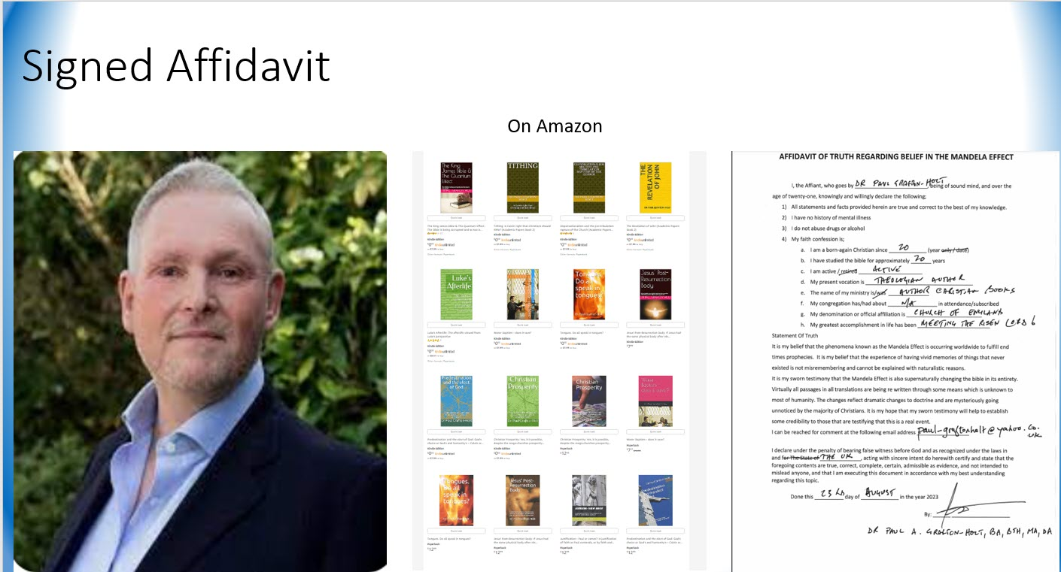

Here’s a Bible scholar that has written a book claiming that the Bible is supernaturally changing. His name is Dr Paul Grafton Holt. He has four theological degrees including a PhD in theology. Here’s his signed affidavit attesting to the fact that the Bible is supernaturally changing.

He's written 12 academic theological books some of which are used in bible colleges as curriculum. One of his books is called “The King James Bible and the quantum effect” where he outlines that this is in fact happening despite everyone’s long held doctrine that the Bible can’t change and does so from a very authoritative position. His books are available on Amazon

One of the most common arguments against this idea of the Bible coming under judgement by God is that anyone claiming it is just confused because they're biblically illiterate, but in order for that argument to have any validity you would have to be able to make it work with Dr Holt.

And I think it would be ill advised to attempt to disregard his testimony by attempting to disparage him somehow without even looking into who he is, wouldn’t you agree? (wait for an answer)

I can send you an interview that he did with Wakeuporelse if you like. Ill send you the link

Holt Interview

<https://www.youtube.com/watch?v=WnrjA7B_QK0&t=15s&ab_channel=WakeuporelsePMA>

Objections of the unconvinced

Here are most of the reasons that we are given in an attempt to explain away our testimony and our evidence. What we are commonly told is

* God preserves His word - the Bible can’t change
* The devil isn’t that powerful
* You’re misremembering
* The human memory is unreliable
* You’re confused by all the different versions
* You’re confused because you’re biblically illiterate
* You’re confused by misquotes from pop culture
* You’re confused by modernization
* You’re confused by misprints
* You’re confused by implanted thoughts (Planter’s peanut guy vs monopoly guy
* You’re delusional
* You’re a charlatan or deceiver (In it for the money)
* You’re deceived by a government psyop
* You’re deceived by photoshopped tricks on the internet

However, the evidence that there is a phenomenon now seems to be irrefutable and I think that anyone that denies that something unexplainable is happening is going to have to lie to themselves to maintain that position

The evidence

1. This phenomenon is huge
   1. There are millions claiming that this is happening.
   2. There are many changes in many different forms to the Bible and they are obvious
2. Then there is Testimonial evidence
   1. The mathematical probabilities prove that there's a phenomenon because everyone remembers hundreds of different things the exact same way, and that’s not possible
3. We also have Biblical prophecy predicting this event
4. We have numerous examples of God withdrawing His word as a judgement before
5. There have been four “flip flops” that amount to documented real time observations. Things changed and then changed back again in front of everyone.
6. Residual evidence which has no explanation

## Large scale of the phenomenon

This is not a few crazy people in their mom’s basement that is being amplified by the internet. This is not a few unlearned YouTube Christians that are biblically illiterate so it’s not even worth looking into. There are hundreds of channels across all the social media platforms that report on the Mandela Effect. Many of them are Bible based. Some of the larger Mandela Effect YouTube channels have as many as two hundred thousand subscribers each. Facebook has close to one hundred groups with thousands of subscribers in each group.

There are movies about the Mandela Effect. Major magazines like *Reader’s Digest*, *Popular Mechanics*, *Good Housekeeping*, and *Parade Magazine* have all done full-page spreads covering the phenomenon. Fox News has covered it, and Google Analytics shows a huge uptick in searches for the term Mandela Effect around July 2017.

## Vast number, severity and variety of changes

* New names and new places.
* There are names with eighteen letters.
* There are word switches,
* New countries,
* Missing words,
* Altered names,
* Egregious spelling, grammar, and syntax errors galore,
* Changed stories,
* New stories,
* Biblical paradoxes,
* Cut-and-paste duplicates,
* Ebonics,
* Emojis,
* Gibberish, and nonsense verses.
* Duplicated words, massive run-on sentences,
* Modern words,
* Unexplained use of capitalization and italics,
* Blasphemy,
* Sexual innuendo,
* Ungodly themes,
* Certain versions contain changes not present in the KJV, while at other times, changes only appear in the KJV.
* Some changes appear in one part of the New Testament but not in another part of the same New Testament.
* Some changes are in the Old Testament but not in the New Testament, and vice versa.
* Some changes are in one Gospel but not in any others, while other changes are in all Gospels.
* Some changes dramatically impact doctrine, while others are benign.
* You can see the same Greek or Hebrew word represented by two different English words in the same paragraph.
* There are changes that only occur one time, while other passages have changed, and then change again.
* We also see changes on major Bible websites like Biblehub that do not appear on other sites like Biblegateway or Bible.com in the same versions.
* Another type of change that seems to trick a lot of people is the multiplication of something that was always in the scripture pnly once or twice.

Examples of this are references to

* Cannibalism
* Pissing against the wall

## We’re not delusional

Any suggestion that this can be explained by the idea that we are just delusional needs to be set aside because a peer reviewed study on the Mandela effect showed that both groups shared the same memories. Therefore, if we are delusional then so are you. See the study titled: *“The Visual Mandela Effect as Evidence for Shared and Specific False Memories Across People”* (Page 448 of my book)

## Testimonial evidence & mathematical probabilities

The best evidence that we have by far is that all of humanity is misremembering hundreds of things in a variety of categories including the Bible the exact same way

Normal misremembering would not be so perfectly aligned where everyone is misremembering in unison. This has been proven in various sociological studies and in our life experience. There would have to be a vast difference in the memories of so many people across so many different things from so many people, so many different ages, regions cultures and demographics. We have also been able to prove the impossibility of this mathematically using chat GPT by asking the following question.

### Chat GBT Question

*“Calculate the probability that five people would answer five simple fill in the blanks Bible quiz questions incorrectly and that they would all misremember the exact same way. In other words, all of their answers would be incorrect but identical.*

*Assume that there are only 50 possible answers for each question*

*Assume that the people are not given a multiple choice option but are coming out of their own long-term memory*

*Assume that each person has an above average knowledge of the Bible*

*Repeat the calculation with all of the same parameters but now expand the number of questions to 10 questions and 10 people*

*In this example all 10 people answer all 10 questions incorrectly but they all provide the exact same incorrect answer*

*When do you display the answer first display it in a mathematical format and then convert that to a format that is 10 to a certain power*

*Provide a baseline for our understanding in layman's terms*

*For instance, say 10 to the 18th power is one in quintillion then convert your answer to a similar expression.”*

### Chat GBT Answer

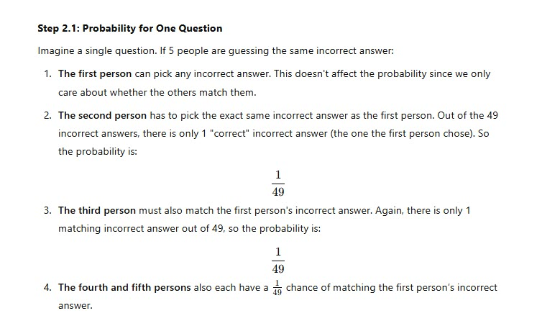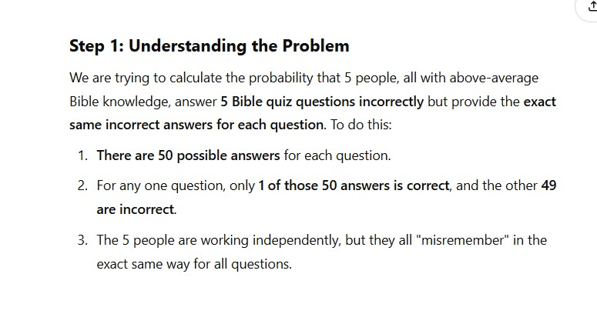

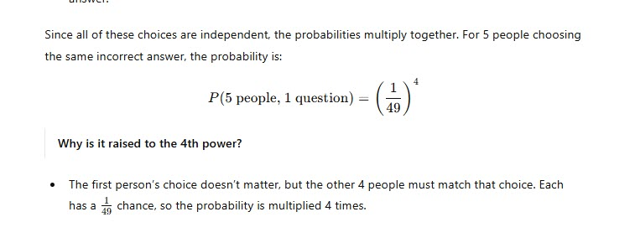

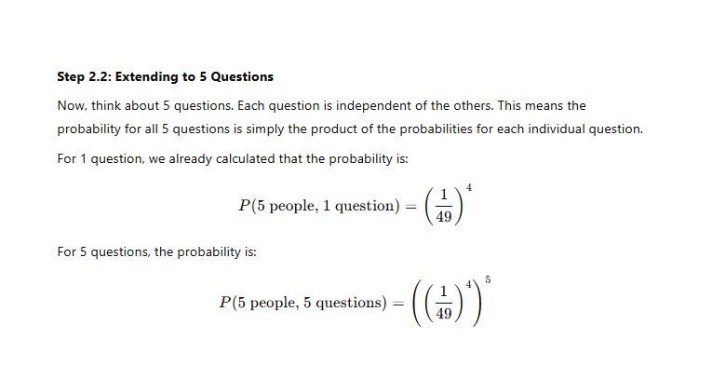

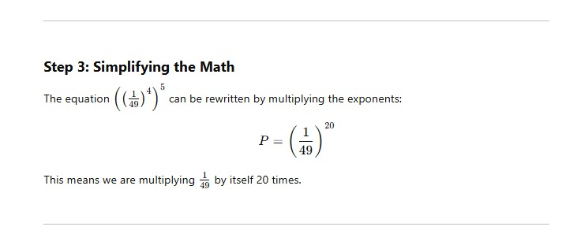

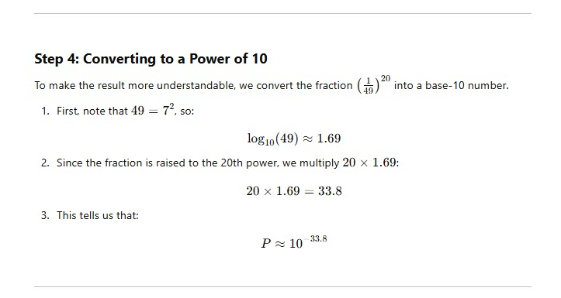

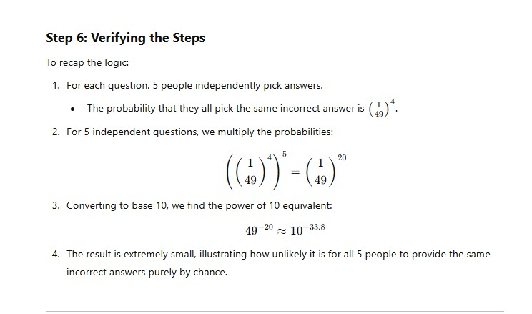

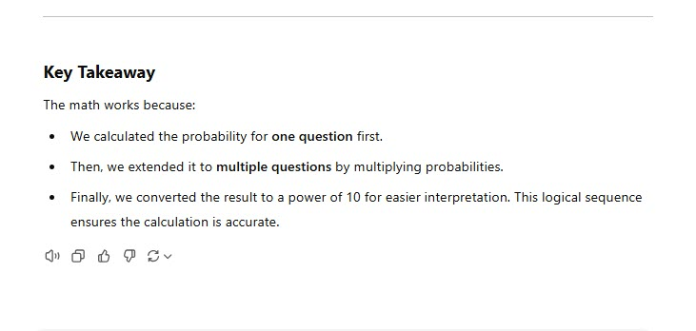

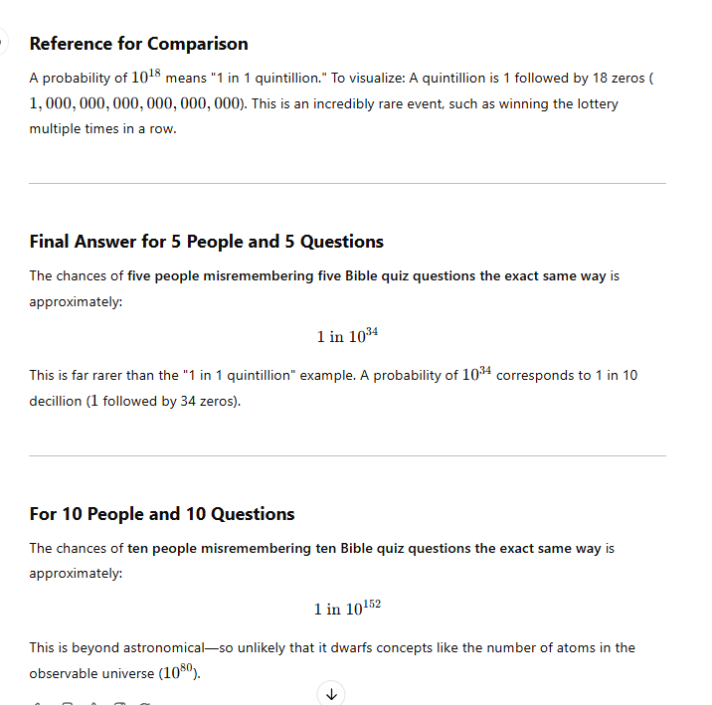

## Take the quiz

I will ask you some fill in the blank Bible quiz questions. They are very familiar passages, so if you get them wrong the same way everyone else does, you will demonstrate to yourself that you are affected, and that this is not simple every day, run of the mill misremembering. You will have proven to yourself that this is a phenomenon. These first two are King James only verses.

**Versions, modernizations or misprints**

It is also very important to recognize that the universal changes are in all versions including the KJV 1611 Cambridge Version, all 5 revisions, the 1769 Oxford version the NIV, NAS, ESV, CSB, CEV Etc. They are in every version, therefore if everyone misremembers the universal changes the same way, then the argument that we are confused by different Bible versions, modernizations or misprints must be set aside.

KJV Only

* Matthew 7:1 (KJV): “Judge not ______ ye be judged.” (Lest)  
  **Actual**: "Judge not, that ye be not judged."
* Job 1:21 (KJV): “The Lord _____ and the Lord ______ away.” (Giveth / Taketh)  
  **Actual**: "The Lord gave, and the Lord hath taken away; blessed be the name of the Lord."

Universal Changes (Most translations)

Exodus 12:23 Who went in and killed the firstborn of Egypt? **(The death Angle)**

* Exodus 12:23 “For **the LORD** will pass through to smite the Egyptians; and when he seeth the blood upon the lintel, and on the two side posts, the LORD will pass over the door, and will not suffer the destroyer to come in unto your houses to smite you.”

Genesis 32:24 - Who did Jacob wrestle with all night? **(An Angle)**

* Genesis 32:24 “And Jacob was left alone; and there wrestled **a man** with him until the breaking of the day.”

Isaiah 11:6 - Who laid down with the lamb? **(Lion)**

* Isaiah 11:6 “**The wolf** also shall dwell with the lamb, and the leopard shall lie down with the kid; and the calf and the young lion and the fatling together; and a little child shall lead them.”

Genesis 8:11 - What did the dove bring back to Noah to indicate that land was nearby? **(Branch)**

* Genesis 8:11 “And the dove came in to him in the evening; and, lo, in her mouth was an **olive leaf** pluckt off: so Noah knew that the waters were abated from off the earth.”

Isaiah 8:3 - Do you remember Isaiah having sex with a prostitute and having a baby? (No)

* Isaiah 8:3 **“And I went unto the prophetess**; and she conceived, and bare a son. Then said the LORD to me, Call his name Mahershalalhashbaz.”

Matthew 18:20 - For where two or ______ are gathered together in my name, there am I in the midst of them. **(More)**

* Matthew 18:20 “For where two or **three** are gathered together in my name, there am I in the midst of them.”

Hosea 4:6 - My people ______ from lack of knowledge **(Perish)**

* Hosea 4:6 “My people are **destroyed** for lack of knowledge.”

**Bonus questions**

Mark 8:23 – Do you remember Jesus making mud with his spit and then healing a blind man? Do you remember him spitting directly into a man’s face to heal him? **(No)**

* Mark 8:23 “And he took the blind man by the hand, and led him out of the town; and when he had **spit on his eyes,** and put his hands upon him, he asked him if he saw ought.”

Leviticus 4:32 - Did God ever instruct his people to sacrifice female sheep?

* Leviticus 4:32 “And if he bring a lamb for a sin offering, he shall **bring it a female** without blemish.”

Luke 18:15 - Did they ever bring babies to Jesus for Him to touch them? (NOTE: Not children to bless… babies to touch)

* Luke 18:15 “And they brought unto him also **infants, that he would touch them:** but when his disciples saw it, they rebuked them.”

## If they got at least five (5) wrong the same way

The fact that you answered at least five incorrectly the same way that everybody else does proves that this is not simple misremembering and that you yourself are experiencing the Mandela effect.

Unfortunately, because most Christians refuse to allow their doctrines to be challenged, they will not accept this evidence and so its very common that they will try to suggest that the reason the entire world is misremembering in unison is because the whole world is confused by misquotes from pop culture. Is that what you believe?

Misquotes from pop culture (Telephone game)

Keep in mind, you got them all wrong just like everyone else so you are suggesting that this brainwashing from pop culture is happening to you as well, is that your testimony?

As we get into this, I think you will see the absolute impossibility of this idea. Anyone suggesting this has not really thought it through past the first statement. How gullible and prone to implanted thoughts do you really believe everyone is. You included

* For instance, If you hear someone say that there is no God on Facebook, are you somehow strangely overcome by this and then subconsciously adopt this belief without even being conscious that it’s happening. And then you wake up one day as an atheist. That’s what we’re being asked to believe.
* Can you quote just one scripture from memory? How many times do you think you would have to come across a misquote of that scripture before it would be able to take over your mind and brain wash you into thinking that that’s what your Bible actually says. Do you honestly believe that it is even possible for one scripture much less 10. And then that same thing happening with not just you but the entire world?
* So what if I see a misquote in pop culture…. I know my Bible. Don’t you?
* God has not given me the spirit of fear but of power love and sound mind.
* God commands me to remember 8 times
* What’s ironic is the same people that are trying to explain away our testimony by suggesting that we are biblically illiterate are the same people that are trying to suggest that they themselves are so vulnerable to misquotes from pop culture that they are also having their own knowledge of the scripture magically overwritten en masse
* And were not talking 1 or 2 scriptures, and were not just talking about lay people only this is pastors and theologians as well.
* Let me illustrate how impossible this is using an example from pop culture. Everyone remembers the movie snow white and the seven dwarfs where the witch says “mirror mirror on the wall,” but the witch never said that. What she actually said was “magic mirror on the wall.” So in order for this hypothesis to be convincing you would have to be able to produce the movie that is causing all of this confusion. Can you name the movie where a cartoon character is in front of a mirror saying “mirror mirro on the wall” Can you produce the so called misquotes for another 20 known Mandela effects from pop culture.
* This same reasoning goes for all the Bible scriptures that we know have changed. If we’re just confused by misquotes from pop culture than let’s see them. Produce biblical examples of the misquotes from pop culture for all scripture questions I just gave you. If you cant easily find the misquotes then your theory is set aside.
* So if we’re not misremembering or delusional and its not implanted thoughts from pop culture what is your explanation for how everyone is misremembering their bibles the same way?
* You agreed there would have to be a cause for that, so what’s the cause
* In order for your theory to work there would also have to only be one misquote for each recognized Bible change. Do you have any proof of that?
* It would also have to be repeated enough times over decades to overcome everyone’s influences of Bible study, memorization, singing of hymns, reading devotionals etc. Forget about all the disciplines of a pastor that has to prepare and deliver regular sermons as well. Do you have any evidence that’s these alleged misquotes are being repeated enough to overcome all of the disciplines of our faith?

### Is the human memory is unreliable?

In an effort to support the idea that we are just misremembering, it is often suggested that the human memory is unreliable. Anyone saying this however doesn't even believe it themselves. Here’s how you can know that is true.

If you visited your aging parent and they didn't recognize you, what conclusion would you draw?

Did you say Alzheimer’s or dementia?

The reason you said that is because you believe that the human memory is so reliable when it comes to vivid memories, that the only explanation for a parent not recognizing their own child’s face would be mental illness. This means that your testimony is that the human memory is extremely reliable when it comes to vivid memories. And yes, I have peer reviewed studies that prove that Mandela Effect memories can be as vivid as a parent’s memory of their own child

## Once misremembering, misquotes from pop culture, delusion, confused by bible versions, modernization and misprints, implanted thoughts, biblical illiteracy have all been set aside

If after reviewing this information, anyone tries to suggest that the testimony of millions can be explained by misremembering, misquotes from pop culture, delusion, confused by bible versions, modernizations, misprints, implanted thoughts or biblical illiteracy, they will be lying.

The fact that you got at least 5 wrong the same way as the rest of the world should arrest you if you have integrity. So do you? Do you have integrity?

As I have shown, it’s a mathematical impossibility and there has to be some sort of causation for everyone's memories to be identical

* Would you agree that all the trees in a large forest do not typically just fall over without some sort of causation?
* **In a similar way, as the math has proven, would you agree that an event like this, which has never happened before in recorded history involving millions of people over a seven-year period, where everyone misremembers the same way would also require some sort of causation?**
* Wouldn’t it also be a phenomenon, even if you are right, and millions of people are claiming that their reality is changing when they’re really just misremembering?
* If millions of people can’t misremember the same way by chance, then what’s causing it?
* Would you agree that a virus, mind weapon, or demonic attack causing delusion would be examples of a cause for the event, whereas delusion or misremembering are simply the results of a cause? In other words, you have to explain how millions suddenly became delusional for your argument to appear rational.
* Would you agree that since you have no evidence to prove the cause of this event, you are forced to admit that the cause of this event is unknown to you?
* Would you agree that being able to rationally explain the cause of this event represents the foundation for formulating a strong argument?
* Would you agree that without understanding how or why your hypothesis was formulated, that your argument lacks credibility?
* Would you agree that if you suggest that people claiming this are simply misremembering, but at the same time you are admitting that the cause of the mass event is unknown to you, that your position embraces a known and unknown cause at the same time?
* Misremembering = (known cause / natural)
* Phenomenon = (unknown cause / supernatural)
* Would you agree that if you try to maintain two diametrically opposed positions, your argument would appear to be conflicted and unconvincing?
* Based on the last question, would you agree that integrity demands that you would need to decide what the basis of your argument is going to be? I.e. Naturalistic or phenomenon
* So……do you believe the cause is misremembering (naturalistic) or phenomenon (unknown)? Which one are you going to pick?
* Answer #1: I choose misremembering.
  + Then you still haven’t explained to us what is causing the mass event; therefore, your argument is unconvincing and it is overruled and there is a very high likelihood that the Bible is supernaturally changing
* Answer #2: I choose an unknown cause.
  + Then you agree we are not misremembering, and the misremembering argument is overruled and there is a very high likelihood that the Bible is supernaturally changing
* If you do not have an alternate explanation for these observations, then do you agree that you have no further objection to our testimony?

***NO! But the Bible can’t change***

* If your answer is no, would agree with the sherlock holms statement that "When you have eliminated the impossible, whatever remains, however improbable, must be the truth,
  + "***My explanation is the Bible can’t change and that’s final***
* ***REBUKE***: If you have no explanation for our evidence but you intend to maintain your public position that there is no evidence that the Bible is supernaturally changing, then I submit that you have a serious integrity problem.

If you cannot provide an explanation for this observable repeatable evidence then would you at least be willing to consider the possibility that our long-held understanding of the terms scripture and term word of God may be different than what we have all been taught. And also, that our understanding of preservation doctrines may need to be reexamined as well?

God preserves His word - the Bible can’t change

(See chapter 5 of my book for breakdown of 7 preservation promises)

The 7 to 10 passages that are being relied on to demand that the Bible can't change are being mishandled.

What most Christians have never considered is that the term scripture and the term word of God are not synonymous. This oversight forms the basis of the widespread misunderstanding that the Bible can’t change.

Evidence that the term “scripture” and the term “the Word” are not the same.

* When most Christians see the term “Word of God,” they immediately convert that term in their mind into the written words that appear in their Bible in English. But when you read John 1:1 *“And the Word was God,”* at least in this one example, you have the most emphatic definition of what “the Word” is, and it’s not the written scriptures. The term Word here is clearly defined as God. *“The Word was with God and the Word was God.”* How can written words on a page be God. They can’t. Therefore, the term “the Word” that appears in your Bible does not always mean the written scriptures. Do you believe that your Bible is God?
* If the two terms are interchangeable, you should be able to use them interchangeably. Read John 1:1-4 but swap the term “scripture” with the term “Word” and see if it bears witness with you. You should be able to exchange them and keep the same meaning.

From this example it would seem that the term “the Word of God” can be understood to mean the expressed will of the Father as seen in Jesus Christ, not your King James Bible in English sitting on your coffee table. The term “Word of God” can mean the written word but it also can mean something much more.

* Genesis 15:1 – This verse uses the term “the Word of God” but it clearly does not mean the written word. It is refereeing to an event where God was speaking. Based on this example, the term “Word of God” can be describing a vital connection to a living God as opposed to a written communication

“After these things the ‘word of the LORD’ came unto Abram in a vision, saying, ‘Fear not, Abram: I am thy shield, and thy exceeding great reward.’”

* Hebrews 4:12: “The “Word of God” is living and powerful, and is a discerner of the thoughts and intents of the heart.”

This is definitely not a reference to the Bible here in Hebrews 4:12. The Bible is unable to understand the thoughts and intentions of its audience; there are only dead letters in the Bible. (2 Corinthians 3:6)

Jesus, on the other hand, says in:

* Revelation 22:23: “I am He who searches the minds and hearts.”

Hebrews 4:12 says “the Word of God searches the hearts,” while Revelation 22:23 says Jesus “searches the hearts”; therefore, we have yet another passage moving us away from the emphasis that the Word of God is the scripture. Here, it is clear that the “Word of God” is Jesus. Let me say that again. The Word of God is Jesus.

The definition of the term “Word of God” is not your Bible!

* Revelation 19:11-13: “And He who sat on him was called Faithful and True … He was clothed with a robe dipped in blood, and His name is called ‘The Word of God.’”

Here the clear testimony of the text is that the scriptures are not the “Word of God.” John didn’t say he saw the Bible clothed with a robe; he saw Jesus. And then he proceeded to give Jesus a name. The name He gave this person was The Word of God.”

A definitive feature of the “Word of God” is that it has and gives life. John says of Jesus:

* John 1:4 “In Him was life, and the life was the light of men”

But Jesus maintains there is no life in the scriptures. He says to the Jews:

* John 5:39-40 “You search the Scriptures, for in them you think you have eternal life; and these are they which testify of Me. But you are not willing to come to Me that you may have life”
* This passage makes a clear distinction between the scriptures and Jesus, who we know is the Word of God. This is another clear indication that the scripture and the Word are not necessarily the same thing. At the very least, Jesus is clearly pointing to the refocusing that needs to take place, which I believe is the impetus behind this catastrophic judgment that God has unleashed on His church.

### Different ways scripture refers to itself

* Scripture(s) KJV | Matthew 22:29
* Holy Scriptures KJV | Romans 1:2
* The writing | Exodus 32:16
* That which is written | 2 King 14:6
* The “Word of God” |Hebrews 4:12
* The word | John 1:1; James 1:22
* The law | Matthew 5:17; Romans 7:12
* The law and the prophets | Matthew 7:12; Matthew 22:40
* Moses & the Prophets | Luke 16:29; Luke 24:27
* The oracles of God | Romans 3:2; Hebrews 5:12
* The Covenant | Hebrews 8:6; Hebrews 9:15
* Book(s) | Daniel 9:2; Revelation 20:12
* Testament | 2 Corinthians 3:6; Hebrews 9:15
* Law of the Lord | Psalm 1:2;
* Commandments | Exodus 24:12; Matthew 22:40
* Precepts | Psalm 119:4; Isaiah 28:10
* Statutes | Leviticus 18:5; Psalm 119:5
* Judgments | Deuteronomy 4:1; Psalm 119:20
* Testimonies | Psalm 19:7; Psalm 119:14
* Ordinances | Exodus 18:20; Ezekiel 11:20
* Words of the LORD | Psalm 12:6
* Book of the Law | Joshua 1:8; Nehemiah 8:1
* Good News (Gospel) | Mark 1:1; Romans 1:16

**Different meanings from original language**

When you see the term “Word” or the phrase “the Word of God” or “the Word of the Lord,” it may mean something different than it did in a different passage. These terms are not always translated from the same Greek or Hebrew words in every case.

* **Logos (G3056)** John 1:1: “In the beginning was the Word (Logos), and the Word (Logos) was with God, and the Word (Logos) was God.”
* **Rema (G4487)** Matthew 4:4: “But he answered, ‘It is written, Man shall not live by bread alone, but by every word (Rema) that comes from the mouth of God.’”
* **Nomos (G3551)** Romans 7:12: “So then, the law (Nomos) is holy, and the commandment is holy and righteous and good.”
* **Dabar (H1697)** Genesis 15:1: “After these things the word (Dabar) of the LORD came to Abram in a vision, saying, ‘Do not be afraid, Abram. I am your shield, your exceedingly great reward.’”
* **Graphe (G1124)** 2 Timothy 3:16: “All Scripture is breathed out by God and profitable for teaching, for reproof, for correction, and for training in righteousness.”

**Different Terms used to describe the different gospels**

Gospel of the Kingdom |Matthew 4:23; Matthew 9:35

Gospel of Jesus Christ | Mark 1:1; Romans 1:16

Gospel of God | Romans 1:1; 1 Thess 2:8-9

Gospel of the Grace of God | Acts 20:24

Gospel of Salvation | Ephesians 1:13

Gospel of Peace | Ephesians 6:15

Gospel of Glory | 2 Cor 4:4; 1 Timothy 1:11

Gospel of His Son | Romans 1:9

Gospel of Christ | Romans 15:19; 2 Cor 10:14

Gospel of the Kingdom of God | Mark 1:14-15

Everlasting Gospel | Revelation 14:6

**Singular vs plural**

Another observation is that we typically refer to the scriptures as “they” (plural) but refer to the Word as “it” (singular).

Example:

* “I hold the Word of God in high regard; it is important to me.”
* “I hold the scriptures in high regard; they are important to me.”
* This observation also supports the idea that these two terms are not synonymous.
* One represents a personal encounter, while the other is a written record. One is living and dynamic, while the other is static and historical.

**Scripture is not the Word**

1 Thessalonians 2:13 is often cited as a proof text that the scriptures are the “Word of God,” but this passage is nothing of the kind. They are not saying that the scriptures are the Word of God; they are saying that the message that they provided orally was received as the “Word of God.” Read it for yourself.

* 1 Thessalonians 2:13 NLT “For this cause also thank we God without ceasing, because, when ye received the word of God which ye heard of us, ye received *it* not *as* the word of men, but as it is in truth, the word of God, which effectually worketh also in you that believe.”

The Bible is a compilation of writings that we refer to as the scriptures, and the scriptures contain the words of God. The scriptures promise that God's word will not change, but they do not promise that the scriptures won’t change. My book goes to great lengths to show convincingly that the term scripture and the term word of God do not mean the same thing. If your willing to accept this, everything changes.

The devil isn't that powerful

The only reason people suggest this is because it hasn’t dawned on them that God is the one calling for this. They immediately assume that we believe the devil has somehow been able to get the upper hand on God. Of course, the devil isn't powerful enough to overcome God, unless God gives him permission. We see this very clearly in chapters 1 and 2 of Job when God gave permission to Satan to overcome Job. We also see permission like this given in Revelation 13. Additionally, we see numerous places in the scriptures where God withdrew his word as a judgment. One example of course is Amos 8:11. This passage clearly demonstrates that God is willing to remove His word as a judgement. If He did it before He would certainly, do it again. And if He does, its not because the devil overpowered Him.

You're confused by different versions

Many of the Bible changes that we all recognize are in all versions so we can't be confused by different versions when we're talking about universal changes. You can find a list of universal changes starting on page 82 of the Supernatural Bible change book. (See Wakeuporelse.com)

These changes are not only in every translation, they are not only wildly unfamiliar, they are also doctrinal paradoxes.

Universal changes would also eliminate the modernization and the misprint arguments. Anyone that makes this claim simply hasn’t done their research and should be ashamed of themselves for treating this important topic with such a cavalier attitude. If church leaders do not stop denying the obvious God is going to remove His hand from you and paint ichabod across the door post of your church.

You're confused because you're biblically illiterate

Biblical literacy has nothing to do with the validity of someone’s testimony of whether or not they believe the Bible is supernaturally changing. The validity of our testimony is based on the reliability of the human memory. Well….God commands you to remember 8 different times in the Bible. Do you think He would command you to do something that you were incapable of doing?

18 US Code 3502 is the law that recognizes the reliability of the human memory. “Testimony is admissible in evidence.” Someone could memorize five scriptures throughout their entire life and never read any other part of the rest of the Bible. By anyone’s standards, these people would be biblically illiterate, however, for those few scriptures, their testimony would be as reliable as someone with a PHD in theology. Wouldn’t it?

You're confused by implanted thoughts

It's very common for people to invoke the Planters peanut guy as an explanation for why we believe the Monopoly guy always had a monocle. They are suggesting that we are confusing the two icons and that we’re just befuddled. But this implanted thought theory is then being recklessly applied to the entire phenomenon. The insinuation is that this implanted thought brain malfunction is happening on a broad scale across hundreds of different things.

It is a huge leap to apply this one example to the entire phenomenon. But in order for this to be possible you would have to produce a surrogate for each of the reported Mandela effects. In other words, I'm not confusing mirror mirror on the wall because of the platters peanut guy.

You're charlatan or a deceiver

This is an outrageous unfounded accusation and any hopped-up preacher that tries this should be ashamed of himself.

How do you know the minds and hearts of hundreds of thousands or millions of Christians. Anyone trying this is going to be guilty of bearing false witness against some of God’s children. Do you really believe that an untold number of Christians are all premeditated liars? That's your explanation for hundreds of thousands and possibly millions of Christians claiming their Bibles are changing? I have heard preachers also claim that the entire Christian Mandela effect community is simply made up of Youtube Christians or pseudo-Christians. The insinuation is that this entire group is so disreputable that no one should pay any attention to them. They will also suggest that anyone speaking out about this topic is just “in it for the money.” Well…my channel is not monetized, my books are free and I don’t sell T-shirts, vitamins or annuities. My wife divorced me and my children barely talk to me. Right now I am living with someone else so I am basically homeless. I’m not in it for the money. God supernaturally spoke to me to do this, so I’m “in it for the fear of the Lord and a zeal for God’s house.

You're deceived by a government psyop

If you want to suggest that we're simply deceived by a government psyop or photoshop tricks, I would simply ask you to explain how. This one level argument has no substance past the initial statement. There’s no way to explain how the government psyop could accomplish what we are experiencing. How did the government get everybody in the world to remember “judge not lest ye be judged” and “the lord giveth and the lord taketh away.” If that’s your theory you have to be able to provide an explanation for how it was carried out.

Prophecy foretelling the event

Most Christians who were confronted with the possibility that the Bible was supernaturally changing had the same reaction. They said, “God, if this is really happening, I’m going to need you to show it to me in the Scriptures.”

Here are four (4) passages that seem to foretell this event. These passages are treated in detail in the Supernatural Bible Change book starting on page 112

* Revelation 22:18 KJV: "For I testify unto every man that heareth the words of the prophecy of this book, If any man shall add unto these things, God shall add unto him the plagues that are written in this book."
* Daniel 12:4 KJV: "But thou, O Daniel, shut up the words, and seal the book, even to the time of the end: many shall run to and fro, and knowledge shall be increased."
* Daniel 7:25 KJV: "And he shall speak great words against the most High, and shall wear out the saints of the most High, and think to change times and laws: and they shall be given into his hand until a time and times and the dividing of time."
* Amos 8:11 KJV: "Behold, the days come, saith the Lord GOD, that I will send a famine in the land, not a famine of bread, nor a thirst for water, but of hearing the words of the LORD."

Examples of where God removed His word as a judgement

It’s not a heresy to suggest that God is allowing the Bible to be changed if He has done this many times before

* **Amos 8:11 “**Behold, the days are coming, declares the Lord GOD, when I will send a famine on the land - not a famine of bread or a thirst for water, but a famine of hearing the words of the LORD.”
* **Lamentations 2:9 “**Her king and her princes are exiled among the nations, the law is no more, and even her prophets find no vision from the LORD.”
* **Psalm 74:9** “We do not see our signs; There is no longer any prophet; Nor is there any among us who knows how long. O God, how long will the adversary reproach? Will the enemy blaspheme Your name forever? Why do You withdraw Your hand, even Your right hand?”
* **1 Samuel 3:1** “Now the boy Samuel ministered to the Lord before Eli. And the word of the Lord was rare in those days; there was no widespread revelation.”
* **2 Chronicles 15:3** “For a long time Israel was without the true God, without a priest to teach, and without the law.”
* **Ezekiel 7:26** “Mischief shall come upon mischief, and rumour shall be upon rumour; then shall they seek a vision of the prophet; **but the law shall perish from the priest, and counsel from the ancients**."
* **Micah 3:6-7** "Therefore night will come over you, without visions, and darkness, without divination. The sun will set for the prophets, and the day will go dark for them. The seers will be ashamed and the diviners disgraced. They will all cover their faces because there is no answer from God."
* **Hosea 4:6** "My people are destroyed from lack of knowledge. ‘Because you have rejected knowledge, I also reject you as my priests; because you have ignored the law of your God, I also will ignore your children.”
* **Ezekiel 14:4** “I, the Lord, will answer him who comes, according to the multitude of his idols, that I may seize the house of Israel by their heart, because they are all estranged from Me by their idols.”
* **Ezekiel 14:9** “And if the prophet is deceived and speaks a word, **I, the LORD, have deceived that prophet**, and I will stretch out My hand against him and will destroy him from the midst of My people Israel.”

Examples of where the Bible changed

This topic is covered in detail starting on page 351 of the Supernatural Bible Changes book. Here are a few observations

If the Bible has been changing since its inception, it’s not heresy to suggest that it’s changing now

**Each new covenant introduces changes to the scripture.**

Covenants for Israel

* Abrahamic
* Palestinian
* Mosaic
* Davidic

Covenants for all mankind

* Adamic
* Noahic
* New

**The Old Testament and the New Testament represents a changing Bible**

It doesn’t matter what narrative you attach to this observation. The pure and simple observation is that the transition from the Old to New Testament introduced “change” into the text.

* Hebrews 8:7-8 "For if that first covenant had been faultless, then should no place have been sought for the second. For finding fault with them, he saith, Behold, the days come, saith the Lord, when I will make a new covenant with the house of Israel and with the house of Judah."

A “new” covenant is a changed covenant.

Scripture modifying scripture

* **Preservation Promise** - **Psalm 12:6-7** “The words of the Lord are pure words, like silver refined in a furnace on the ground, purified seven times. You, O Lord, will keep them; you will guard us from this generation forever.”
* **Modifier** - **Daniel 7:25** “And he shall speak great words against the most High, and shall wear out the saints of the most High, and think to change times and laws: and they shall be given into his hand until a time and times and the dividing of time.”

Daniel 7:25 doesn’t only apply to Psalm 12; it gives theological permission to accept that the whole Bible can be changed. I found that pairing each one directly with a promise helps people see it better.

Let me explain this in layman’s terms. If you’re willing to consider that the Daniel 7:25 prophecy is an end-times prophecy as we discussed in chapter 2, then you can consider that it would modify any providential preservation promises just like the ones we have already examined. That’s what I’m suggesting.

Here are more examples;

* **Preservation Promise** - **Matthew 5:17** “For I tell you truly, until heaven and earth pass away, not a single jot, not a stroke of a pen, will disappear from the Law until everything is accomplished.”
* **Modifier** - **Amos 8:11** “Behold, the days come, saith the Lord God, that I will send a famine in the land, not a famine of bread, nor a thirst for water, but of hearing the words of the Lord.”
* **Preservation Promise** - **Psalm 119:89** “Forever, O LORD, thy word is settled in heaven.”
* **Modifier #1** - **Revelation 13:2** "And the beast which I saw was like unto a leopard, and his feet were as the feet of a bear, and his mouth as the mouth of a lion: and the dragon gave him his power, and his seat, and great authority."
* **Modifier #2** - **Revelation 13:7** “And it was given unto him to make war with the saints, and to overcome them: and power was given him over all kindreds, and tongues, and nations.”
* **Preservation Promise** - **Isaiah 40:8** “The grass withers, the flower fades, but the word of our God will stand forever.”
* **Modifier** - **2 Thessalonians 2:9** “Even him, whose coming is after the working of Satan with all power and signs and lying wonders,”

Patriarch names are not transliterations

Patriarch’s names are altered

Noah (Genesis 6:9) | Noe (Matthew 24:37)

Jeremiah (Jeremiah 1:1) | Jeremy (Matthew 2:17)

Asher (Genesis 30:13) | Aser (Luke 2:36)

Hosea (Hosea 1:1) | Osee (Romans 9:25)

Nebuchadnezzar (2 Kings 24:1) | Nebuckadrezzer (Jer 21:2)

Judah (Genesis 29:35) | Judas (Matthew 1:2)

Shem (Genesis 5:32) | Sem (Luke 3:36)

Gideon (Judges 6:11) | Gedeon (Hebrews 11:32)

Nephtali (Genesis 30:8) | Nepthalim (Matthew 4:15)

John the Baptist (Matthew 3:1) | John Baptist (Matt 14:8)

Elijah (1 Kings 17:1) | Elias (Matthew 17:3)

John (Matthew 4:21) | Joses (Matthew 13:55)

Isaiah (Isaiah 1:1) | Esias (Matthew 3:3)

Timothy (1 Timothy 1:2) | Timotheus (Acts 17:14)

Manasseh (2 Kings 21:1) | Manasses (Matthew 1:10)

Ephraim (Genesis 41:52) | Joseph (Luke 3:30)

Zebulun (Genesis 30:20) | Zebulon (Matthew 4:13)

Boaz (Ruth 2:1) | Booz (Matthew 1:5)

**Noah vs Noe proves that these are not “transliterations (KJV ONLY)**

This KJV only example obliterates the phony backstory that these distorted doppelgangers of the names of all the patriarchs appear in the New Testament because they are transliterations. If this was true, then you would not have Noah and Noe appearing in the same KJV New testament and the same version.

Nobody remembers Noah being called Noe so please stop gaslighting everyone that this is normal. Is this something that you remember always being in your Bible, yes or no?

* Matthew 24:37-38 (KJV) "But as the days of **Noe** were, so shall also the coming of the Son of man be. For as in the days that were before the flood, they were eating and drinking, marrying and giving in marriage, until the day that Noe entered into the ark,"

**Strongs G 3575 no’-eh Transliteration noe**

* 1st Peter 3:20 "Which sometime were disobedient, when once the longsuffering of God waited in the days of **Noah**, while the ark was a preparing, wherein few, that is, eight souls were saved by water.”

**Strongs G 3575 no’-eh Transliteration noe**

If it’s the same word in the original language, which it is, and the Blue Letter Bible says that the transliteration is exactly the same for both words, which it does, then why would the translators translate it as Noe in the Gospels and Noah in the Epistles? The answer is they wouldn’t. It’s been supernaturally changed.

I consulted a renowned Bible scholar, and he said that the two words, which are translated differently into English, are derived from the same Greek word and the same dictionary. They both have the same transliteration, so there’s no rational explanation why it would be transliterated differently in the same New Testament and in the same version.

Some have attempted to explain Noah’s unique spelling of Noe in the New Testament by pointing out that the two audiences were made up of people with different ethnicities. But this is just stuff made up (SMU).

First of all, there is no way to tell from the scriptures what the ethnicity of the two audiences was. Here is anyone’s best guess.

* Matthew 24:37-38 is probably addressed to a predominantly Jewish audience.
* 1 Peter 3:20 is probably addressed to early Christians, a mix of Jews and Gentiles in Asia Minor.

But even if you knew the ethnicity of the audience, what would be the source of this conclusion? How would someone making this claim know that the translators were operating by this rule? The King James translators had fifteen rules that they operated by, and none of them gives any instruction to consider the ethnicity of the audience when choosing how to translate a name into English.

The answer is that someone making this claim doesn’t know. The fact that Noah is rendered Noe is one of the most compelling examples of a supernatural Bible change that I know of because:

* Both passages are translated from the same Greek word.
* Both passages have the same transliteration.
* Both passages appear in the same version.
* Both passages appear in the same New Testament.
* Most Christians do not remember this ever being in their Bibles this way.